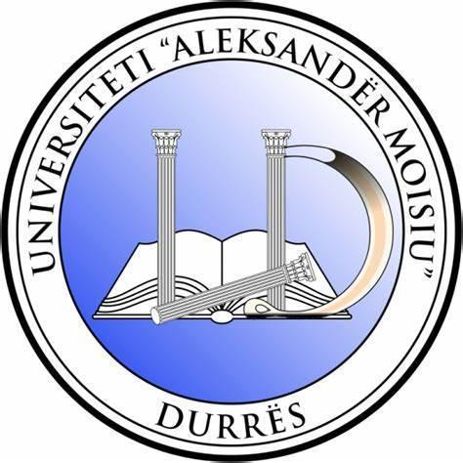

CALL FOR PAPERS

16th International Scientific Conference of Business Faculty

Organized by
Business Faculty
University “Aleksandër Moisiu” Durrës, Albania

“AI and Sustainability-Driven Transformation: Reshaping Business and Society on the Path to EU Integration”

April 28-29, 2026
Durrës, Albania
www.uamd.edu.al

In collaboration with our esteemed partners:

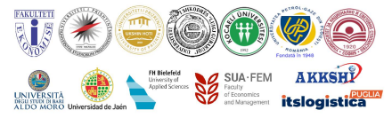

GENERAL INFORMATION

Conference aim

The conference aims to explore how Artificial Intelligence is accelerating the transformation of business, public services, and society, and how these changes can support countries and institutions on their path toward EU integration. It will provide a platform for researchers, policymakers, industry leaders, and practitioners to exchange evidence, good practices, and policy recommendations on AI-enabled innovation, productivity, and competitiveness, while ensuring alignment with EU standards on ethics, governance, data protection, and responsible digitalization. By connecting academic insight with real-world applications, the conference seeks to foster cross-border collaboration, strengthen capacities, and contribute to sustainable, inclusive, and resilient economic development in the EU integration context.

Language: English

Venue: Business Faculty, University “Aleksandër Mosiu” Durrës, New Campus, Spitallë, Durrës.

Conference Subtopics

1) AI and Economic Transformation for EU Integration
- AI as a driver of economic modernization and convergence with the EU
- Productivity, competitiveness, and sectoral transformation
- Opportunities, risks, and policy implications for candidate/candidate-like economies

2) Innovation, Digital Transformation and Industry Modernisation
- Innovation ecosystems, digitalisation, and new business models
- Entrepreneurship, startups, and technology transfer
- AI adoption in organisations: change, maturity, and digital capabilities

3) Management, Governance and Evidence-Based Decision-Making
- Strategic management and competitiveness in the AI era
- Data-driven decision-making, performance improvement, and public service delivery
- Leadership, change management, organisational culture, and workforce upskilling

4) Finance, Digital Economy and Trustworthy Data Use
- FinTech, digital finance, and AI-enabled financial services
- Risk management, resilience, forecasting, and decision support
- Cybersecurity, data protection, trust, and responsible data governance

5) Markets, Consumers, Skills and Social Impact
- Market transformation, consumer behaviour, and digital customer experience
- AI in marketing, communication, and customer analytics
- Skills, jobs, inclusion, and the societal impacts of AI (future of work)

6) Sustainability, Smart Tourism and Responsible AI
- AI for the Green Deal: sustainability, circular economy, and green innovation
- Sustainable tourism, smart destinations, and experience innovation
- Governance, ethics, and Responsible AI aligned with EU standards

Conference program is not restricted to these themes. We kindly invite proposals on other suitable topics in relation to the conference theme.

IMPORTANT DATES

- February 25th, 2026 Abstract Submission deadline
- March 10th, 2026 Abstract acceptance notification
- March 25th, 2026 Fee Payment deadline
- April 10th, 2026 Full paper submission deadline
- April 15th, 2026 Power Point presentation submission

CONFERENCE FEE
Participation for UAMD full-time and part-time academic staff, and doctoral students is free of charge.
Participation for academic staff from partner universities and their doctoral students is free of charge.
For other participants: conference fee is 50 € per paper.
For doctoral students from other universities: conference is 25 € per paper.
N.B Doctoral students need to provide upon abstract acceptance a certificate of enrolment in a Doctoral Degree program.

Bank Account Details:

Account owner: TE ARDHURAT E THESARIT DURRES
Bank Name: Credins Bank, Durres, Albania
IBAN: AL97 2121 2110 0000 0000 0050 3907
SWIFT CODE: CDISALTRXXX
During the payment should be mentioned the note: ISCFB 2026, name and surname of participant.

Participants should cover their own travel costs to and from Durrës, and should directly book accommodation in Durrës. We will further suggest your suitable accommodation options.

AUTHORS GUIDELINES

- Abstracts, written in English, should be no longer than 10-18 lines up to 300 words, The abstract should contain JEL classification and up to 6 keywords.

- Abstract format and full papers format will be downloadable at the website of the university. One paper can have a maximum of three authors. One author can present a maximum of two papers.

- Papers will be included at the Proceedings of the Conference. Proceedings of the Conference will be published under a special issue of International official Journal of “Aleksandër Moisiu” University, Interdisciplinary Journal of Research and Development (IJRD).

- Further publication opportunities will be provided for indexed journals.

- Presentations may be delivered either online (virtual) or on-site (in-person).
- For further information, please contact us at: iscbf@uamd.edu.al.

ABSTRACT SUBMISSION

Click link for submission

https://docs.google.com/forms/d/e/1FAIpQLSdvc41s3uohIrdwyVfnrmS4xYmfQ3Ybir4sjkIqbRsYgjJcVg/viewform?usp=preview
Scan for submission
