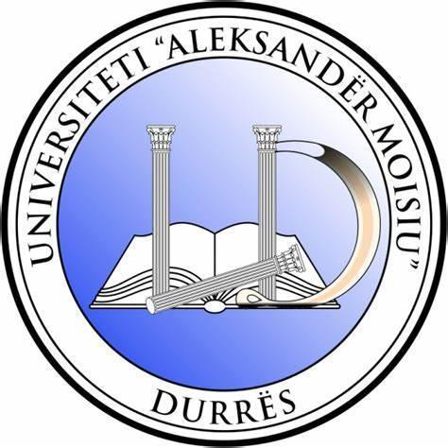

INTERNATIONAL WEEK

“Connecting People, Empowering Partnerships”

Organized by
Business Faculty
University “Aleksandër Moisiu” Durrës, Albania

IW2026 dates: 27 – 30 April 2026, Durrës, Albania
Venue: UAMD campus, Spitallë, Durrës

GENERAL INFORMATION

The Faculty of Business, “Aleksandër Moisiu” University of Durrës (UAMD), warmly invites you to take part in International Week, a dynamic academic and networking event that brings together academics, researchers, students, and institutional partners from Albania and abroad. The week is designed as a platform for sharing best practices, strengthening international cooperation, and promoting meaningful exchange of ideas and experiences in teaching, research, and innovation. Through a rich programme of activities, including workshops, open lectures, networking meetings, and thematic sessions, International Week aims to foster new partnerships, support the development of joint initiatives, and contribute to the ongoing process of internationalisation within higher education and beyond.

Main Objectives
- Promote international collaboration and knowledge sharing among participants.
- Link digital transformation and sustainability to higher education modernization.
- Generate concrete project ideas under Erasmus+, Horizon Europe, and regional cooperation programs.
- Enhance staff competencies in project management, research excellence, and innovation-driven partnerships.
- Strengthen student awareness of mobility opportunities through guidance provided by International Office participants from partner universities.
- Create a collaborative, inspiring environment for dialogue, creativity, and institutional growth.

Spotlight on Partnerships
Format: Short presentations (6 minutes + 3 Q&A).
Focus: partner presentations, successful collaboration models, lessons learned, and innovative partnership examples.

Speed-dating – “Questions That Move Us”
Purpose: stimulate idea generation and deep networking.
Setup: 10 minutes per round, rotating participants, and hosted discussions.

Workshops & Interactive Sessions: Topics and facilitators will be confirmed in the coming weeks and will be shaped based on participants’ registration interests and partner availability.

Upcoming in the programme:
Integrated sessions of the 16th International Scientific Conference of the Faculty of Business (ISCFB 2026); “AI and Sustainability-Driven Transformation: Reshaping Business and Society on the Path to EU Integration”. A detailed agenda will be announced soon.

Project Showcase Session: National & International Projects at UAMD (Research, Innovation and Beyond)
Purpose: This session presents an overview of UAMD’s engagement in national and international projects, including research and scientific initiatives as well as capacity-building, innovation, and institutional development projects. Participants will have the opportunity to see ongoing and completed projects, identify synergies, and explore new collaboration opportunities.
Special focus: Presentation of the NAWA project (objectives, partners, activities, and expected results).

REGISTRATION & PARTICIPATION DETAILS
Who can be part of the international week?
- UAMD academic and administrative staff;
- Academic staff and researchers from universities;
- PhD candidates and early-career researchers(ECIs);
- Students (for dedicated activities and/or subject to capacity);
- Representatives of businesses, Chambers of Commerce, and public institutions (depending on the topics).
- International office representatives.

How to register
Please complete the online registration form:
https://docs.google.com/forms/d/e/1FAIpQLSeCfLNVaN6mUWJd5Ex-DqWPy3bXWOhgcOus_APkxVBICu7bCQ/viewform?usp=header

Registration deadline: [28/ February/2026]
Note: Participation may be on-site (in-person) or online (virtual), depending on the activity and confirmation by the organisers.

Important dates (indicative)
Date | Activity
23/December/2025 | Registration opens
28/ February/ 2026 | Registration deadline
27/April/ 2026 | International Week

Certificate and additional information
Participants will receive a certificate of participation (subject to attendance/activity and the final participant list). Travel and accommodation costs are covered by participants (where applicable) by Erasmus+ K171 at home institutions fund or any other sources of funding at the home institutions or individual level . The organisers will suggest suitable accommodation options.

Contact
For questions and information: [Email: internationalweek@uamd.edu.al ] | [Tel: +355 69 207 7381]
Faculty of Business, UAMD – Durres, Albania
Scan for registration:
