**Blended Intensive Programme “Peer Support for tomorrow”**

**Tallinn University**

Dear colleagues

We are pleased to welcome you to the Blended **Intensive Programme “Peer Support for tomorrow”** at Tallinn University. We hope the following information will assist you with attending the event and make your stay more enjoyable.

***Contacts at Tallinn University***

*Nele Dobrõš*

*Ingrid Hinojosa*

*Arabella Neostus*

*email: studymobilitycenter@tlu.ee*

**Campus of Tallinn University**

Tallinn University has a campus in the central city, so it should be within walking distance from your hotel. Our campus has several buildings, and although they are connected, it might be a little complicated to find the right way when you visit the university for the first time.

Tallinn University is very compact. It has everything in one interconnected campus. There are six different buildings: Terra, Mare, Nova, Astra, Silva, and Vita. Even though the addresses might be different for each building (Narva mnt 25, Narva mnt 29, Narva mnt 27, Uus-Sadama 5), they are still part of one campus. Only the academic library is away from the main campus (Rävala pst 10).

The address of the university is Narva mnt 25 and most of our meetings will take place in the Mare building. If you decide to take a taxi to the university, it would be easier to give them the address Uus-Sadama 5 for the Mare building.

Campus map: <http://www.tlu.ee/en/university/campus>

Wifi access on campus: TLU network (no password needed) or Eduroam

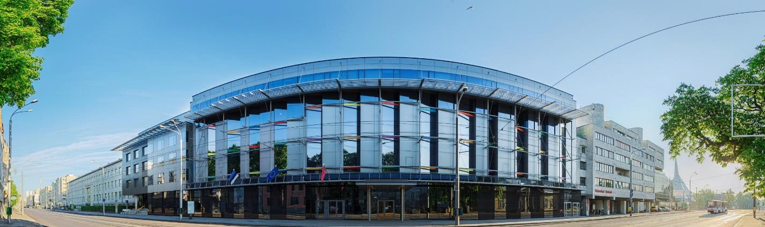

**Public transport in Tallinn**

The public transport network in Tallinn includes buses, trolleys and trams. Currently, the easiest is to travel from the airport to the city centre is by bus nr 2 or 15 (around 17 minutes). Read more about how to leave the airport [here](https://airport.ee/en/parking-transport/).

In Tallinn, UBER and Bolt are also available. Best known taxi companies are Tallink Takso and Tulika takso. All taxi drivers are obligated to give you a receipt at the end of the drive. At the airport, only licensed taxis are available. Be sure to ask the driver the approximate fee from point A to B before choosing the taxi to avoid confusion later!

**Welcome to Tallinn!**

The population of Tallinn is 437 811 (2022). The official language in Estonia is Estonian. Russian, Finnish, English and German are also understood and widely spoken.

Tallinn is a compact city where you can enjoy nice walks in the parks or the seaside. Our Old Town is world-known and belongs to the UNESCO Heritage list. The city has several districts which have unique features and what we would recommend to visit:

* Kalamaja and Telliskivi area – hipster district with a lot of restaurants and bars. There is also a Balti Jaam market and many design shops. Attracts a lot of diverse visitors and is close to the train station.
* Kadriorg – the biggest park in the city with the Presidential Castle, and several museums (KUMU, Kadriorg Art Museum etc.). There are several coffee shops and restaurants.

The most comprehensive list of events taking place in Tallinn and what to do and see is available from here <https://www.visittallinn.ee/eng/visitor>.

**Map of Tallinn: http://kaart.tallinn.ee/Tallinn/Show?REQUEST=Main&lang=eng&WIDTH=1132&H EIGHT=441**

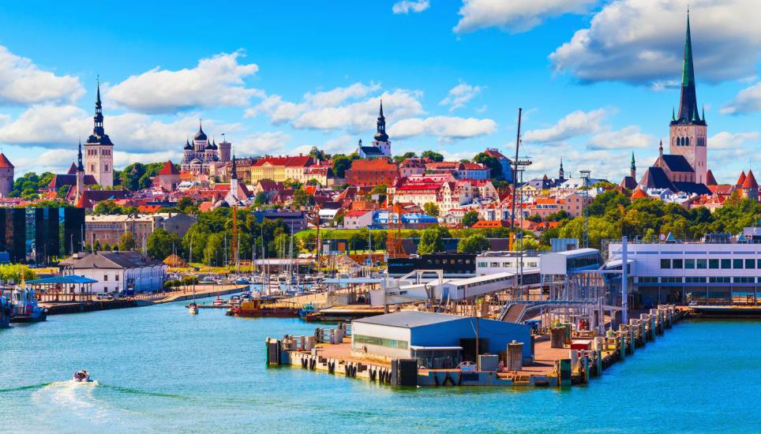

**Good to know**

Currency: euro. Banking cards are used widely and are accepted also in taxis.

Time zone: Central Europe standard time: GMT+2

Electricity: The electricity supply in Estonia is 220 volts AC, 50 Hz. European-style 2-pin plugs are in use.

Weather: <http://www.ilmateenistus.ee/?lang=en>

Security: Although common sense is advisable wherever you go, there is no particular reason to be excessively worried while visiting Estonia. But it is probably not advisable to walk through unlit or abandoned areas alone at night. Pickpockets may operate in crowded tourist destinations in Tallinn, so make sure your wallets, purses and documents are stored safely.

Shopping: shopping centres are opened usually every day from 9-21, supermarkets from 8-23

Emergency Calls:

* Fire and rescue service 112 (free of charge).
* First aid, ambulance 112 (free of charge).
* Police 112 (free of charge).

**Accommodation**

Here are just some recommendations very near the university campus, but Tallinn University is only around 10 minutes walking distance from the city centre, thus, any hotel in the city centre is not that far away.

* [Park Inn by Radisson Central Tallinn](https://www.radissonhotels.com/en-us/hotels/park-inn-tallinn) (about 10 minutes walking distance)
* [Hestia Hotel Europa](https://www.hestiahotels.com/europa/) (about 15 minutes walking distance)
* [Hestia Hotel Seaport](https://www.hestiahotels.com/europa/) (about 10 minutes walking distance)
* [Hotel Metropol](https://www.metropol.ee/) (about 15 minutes walking distance)
* [Nordic Hotel Forum](https://www.nordichotels.eu/) (about 20 minutes walking distance)
* [Center Hotel](https://centerhotel.ee/?lang=en) (a basic and cheaper hotel - about 5 minutes walking distance)

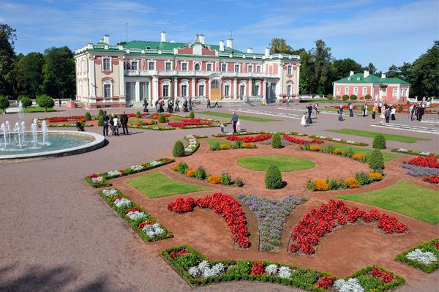

**Five reasons**

Here are five reasons why Estonia is a wonderful place to visit and get to know, from [www.studyinestonia.ee](http://www.studyinestonia.ee):

**Perfectly natural**

Almost a third of all Estonians live in the capital city – Tallinn. And yet we never feel overwhelmed by the hustle and bustle of city life, because wherever you are in Estonia, untouched wilderness is only 30 minutes away. Over 50% of the country is covered in forests, the air quality is one of the best in the world, and yet you still get the big city feel while walking between the skyscrapers in Tallinn. Usually, those two things don’t go together, but Estonians wouldn’t have it any other way!

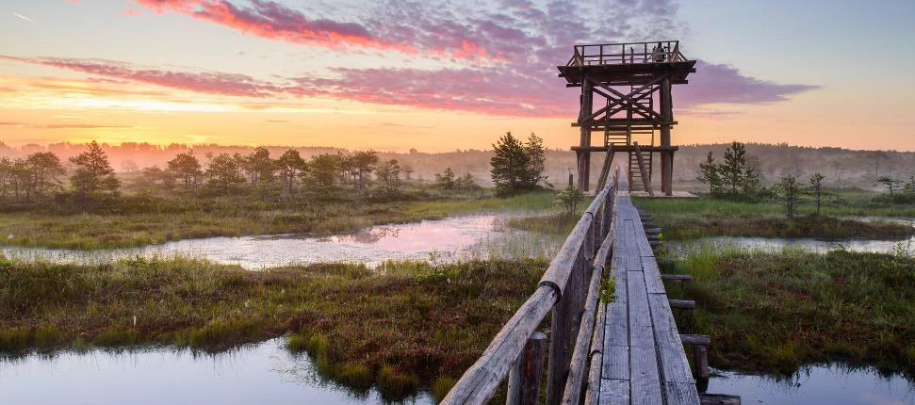

**Digital everything**

Estonians hate unnecessary bureaucracy. Don’t get us wrong, we still occasionally need to fill in some paperwork or stand in a long line at the bank, but most things we can get done online in the comfort of our own homes in just a few minutes. Whether you’re checking your bank balance, applying for a scholarship, declaring your taxes, or voting ([yes, even that](https://e-estonia.com/solutions/e-governance/e-democracy/)) – it’s as easy as opening Instagram on your smartphone. We even went as far as to start an [e-residency program](https://www.e-resident.gov.ee/), which means anyone in the world can become a digital citizen of Estonia.

**Excellent education**

As Estonia is such a small country, we need to come up with innovative solutions on how to be more efficient and productive. We rely on the new generations to keep improving the Estonian way of life, which is why education is so important. Luckily, we must be doing something right because according to the Programme for International Student Assessment (PISA), the knowledge and skills of Estonian 15-year-olds in biology, geography, physics and chemistry are among the best in the world – the first in Europe and third on the global scale. This quality can also be seen in Estonian universities, as more and more international students (over 10% of the total student number) are choosing to start their studies on forward-thinking and innovative Estonian study programmes such as e-governance and cyber security.

**We are looking forward to seeing you in Tallinn!**