/INFORMACIÓN GENERAL DEL PROYECTO
Tipo de proyecto: Jean Monnet Module
Título del proyecto: European Union and external european action: Latin American, Eastern Europe and Russia
Profesorado procedente de (instituciones): UNIVERSITY OF CADIZ
Responsable: Inmaculada González García

Palabras clave: EU, External Relations, Latin America, Eastern Europe, Rusia

Duración: 01/09/14 – 31/08/17/  Presupuesto: 25.537 € |  | LOGO: 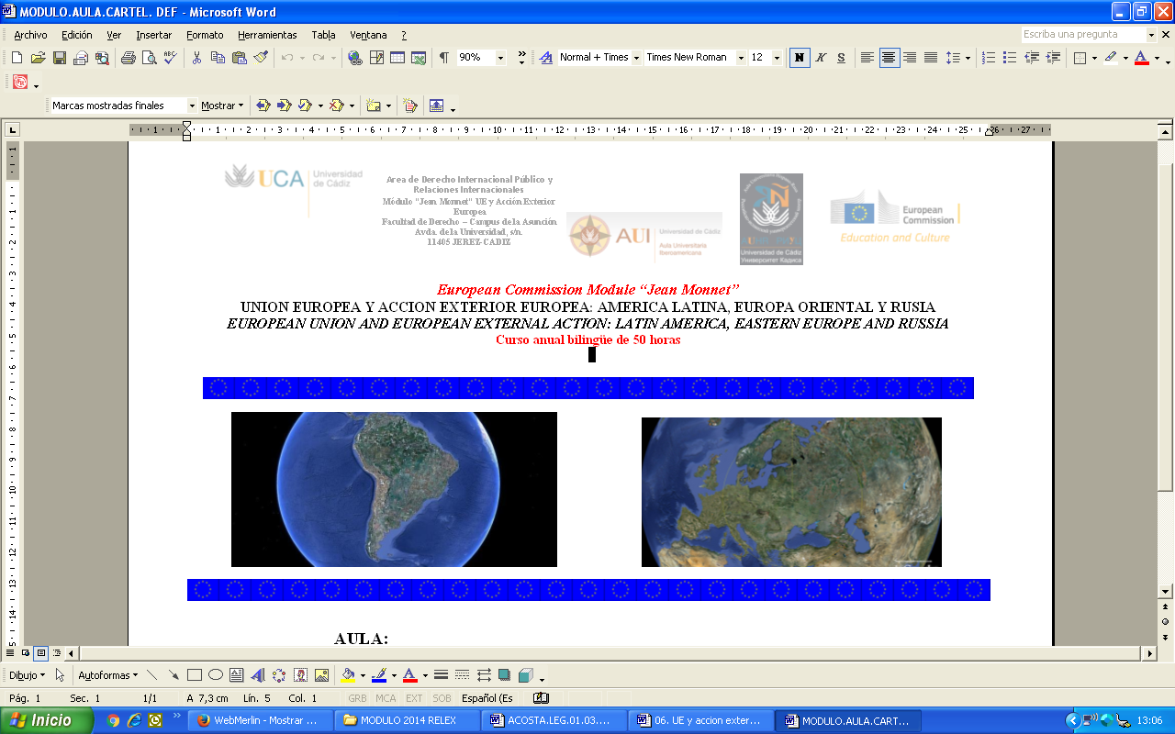  URL:  http://catedras.uca.es/jean-monnet/modulo

RESUMEN DEL PROYECTO
Objective: To disseminate and promote the study of EU tax legislation in a region or country where traditionally it has not been studied or implemented; to promote research outside the EU, outside its scope of implementation.
Expected results and dissemination: It is intended to achieve a strong interaction between the academia, public administrations (national, regional and EU), the judiciary and social partners.
Más info: http://ec.europa.eu/programmes/erasmus-plus/projects/eplus-project-details/#project/c8aff6a1-151d-4529-8524-0814d42c8b8b
Colaboración del equipo de la UCA (100 palabras, en inglés):
The Jean Monnet Module "European Union and European External Action: Latin America, Eastern Europe and Russia", by the University of Cádiz, includes the following activities: ANNUAL BILINGUAL SPANISH AND ENGLISH COURSE, ON EUROPEAN UNION AND EUROPEAN EXTERNAL ACTION: LATIN AMERICA, EASTERN EUROPE AND RUSSIA, developed on the campus of the University of Cádiz, and where there is currently no offer for European Studies. Furthermore, given the fact that the UCA receives more than 150 students from Russia, Latin America and Eastern Europe, the course will focus on the European external relations with these regions, so that to give a first immersion in studies on the process of European integration for all these students. Also, in this module have participated the Hispanic-Russian University Liaison Office and Iberoamerican Univesity Liaison Office. They all pursue the greatest possible impact in the university community and society in general, thus allowing broader participation.

